**Experimental procedure：**

1. Recruit two subjects to participate in the experiment together. Number them as Subject 1 and Subject 2 and inform the subjects of their numbers. Connect the two monitors to each other and set up a mirrored split screen, i.e., both subjects see the same display.
2. At one of the computers, run the test experiment and give the instructions to the two people together. Emphasize in the instructions that the two people are independent of each other's tasks, and that each of them has a corresponding ball number and a key to press.
   1. exec/runExperiment.py, line23, isTestTrial = True

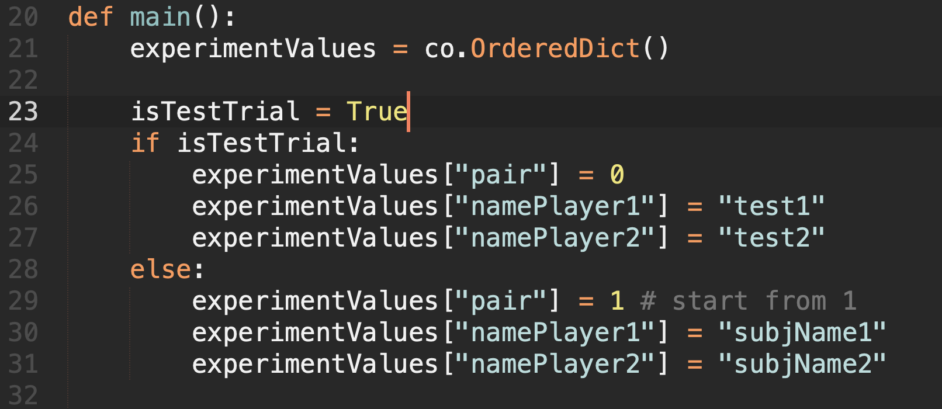

1. Guided participants to sit in two positions (pairs of seats) such that each subject could only see his or her own screen and could not see the other or the other's screen.
2. Press space to start the test trial (3 trials or so), so that the subjects are familiar with their corresponding balls and buttons, and the subjects have no questions to start the formal experiment.
3. Run the formal experiment. subject #1 presses space to start.
   1. Change isTestTrial = False
   2. Line 29, replace "pair" with the nth group from which subjects are currently collected.
   3. Line 30 、31, replace "subjName" with the respective name of the subject.
4. Remind subjects to complete the post hoc questionnaire.